

Southern California Edison
CS Re-Platform Project

CIM-CS-14-Manage Owner Allocation
Customer Interaction Management
Business Process Design
Version 3.9

Table of Contents
1 Business Process Overview 5
1.1 Current Pain Points for Southern California Edison 5
1.2 Responsible Parties 6
1.3 Document Control 6
1.4 Terminology alphabetical order 7
2 Business Process Design 10
2.1 Manage Owner Allocation Details 10
2.1.1 Property Reference Objects 10
2.1.2 Landlord Agreement 11
2.1.3 Property Object 12
2.1.4 Owner Allocation Wait Time 12
2.1.5 Property Number 12
2.1.6 Creating the Owner Allocation 13
2.1.7 Changing the Owner Allocation 15
2.2 Process / Performance Improvement 16
2.3 Prerequisites and Inputs 16
2.4 General Assumptions 16
2.5 Business Process Hierarchy 17
2.6 Process Flows 18
2.6.1 Setting up Owner Allocation 18
2.6.2 Tenant Request for Move-Out 21
2.6.3 Changing Owner Allocation 23
2.6.4 Reversing Owner Allocation 26
2.7 3rd Party and SCE Legacy System Integrations 28
2.8 Data Elements 28
2.8.1 Owner Allocation Data Elements 29
2.8.2 Source Systems and Data Volumes 29
2.9 Cloud for Customer (C4C) Integration 29
2.9.1 Processes 29
2.9.2 C4C Views 29
2.9.3 Activity 29
2.10 Exception Management Requirements 29
2.11 Process Risks and Mitigation 30
2.12 Key Performance Indicators 30
2.12.1 Key Metric Definition 31
3 Controls and Regulatory Rules 32
3.1 Security Considerations 33
3.2 Custom Program/Transaction Codes 33
3.3 Custom Table/Transaction Codes 33
4 Technical Considerations 35
4.1 RICEF-W Assessment 35
1.1.1 Reports 35
1.1.2 Interfaces 35
1.1.3 Conversion 35
1.1.4 Enhancements 35
1.1.5 Forms 36
1.1.6 Workflows 37
4.2 IDEX Considerations 37
4.3 Production System Cut-over Considerations 37
4.5 Other Considerations 38
5 Change Management 39
6. Requirements 47
7. Appendix 48

Business Process Overview
The Manage Owner Allocation process will define how to create, change, display, and reverse a Property for a Business Partner (BP) within SAP environment. This document describes the setup and processing of a Landlord Agreement, which is known as Owner Allocation (OA) in SAP. Creating a Property and allocating the BP as the Owner to that Property creates a logical relationship between the two entities, but it does not establish a Contract for the Owner in and of itself. The relationship information is available as part of the OA process in order to facilitate the move-in of the Owner the day after the tenant moves out of the premise where the owner has an active Landlord Agreement.
OA uses Contract Account (CA) to link the BP with the Property. A BP can have multiple rental premises and can use different CAs for each rental premise.
Within SAP, the property object can consist of one or more Installations, Premises, and Connection Objects.
The OA process is utilized to facilitate agreements with Owners for an automatic New Contract (move-in) into their name so that an Installation is not disconnected when the Premise is vacated by a tenant. OA is triggered when the tenant’s Contract is ended in good faith with one or more installations associated with an active property. The OA process will automatically place the service back into the Owner’s name without additional contact from the owner.
It is possible to create a Property where the OA is strictly for informational purposes with no automatic move-in occurring, however the maintenance of these owner-to-property relationships can often become inaccurate.

Current Pain Points for Southern California Edison
- Customers sometimes forget they have an OA and never cancel the OA, and get a large bill that they want to contest.
- Sometimes renters will never put service in their name because the lights are on. This puts the energy usage on the owner’s bill, then it becomes a civil matter or a bill correction.
- The owner can verbally cancel the agreement, but the phone rep needs to fill out a template and email it to be worked. This process can take about 2-3 days to complete; up to an additional 10 days. It should be instant.
- Agreements that are received via US Mail take more time due to US Mail process.
- Our fax number has changed over the years, yet some customers are still using the old fax number, which delays processing.
- Owner sells but does not notify SCE to cancel agreement and call to contest the bill.
- Front line Energy Advisors are not trained to handle customer requests to sign up, update or cancel owner allocation agreements.
- Cancellation requests for large complexes are very time consuming with solo billed customers.
- Cancelling one unit requires cancelling the entire contract, then reinstating all others. This is an SCE Business Rule today.
- Must wait a day between end of current property owner and beginning of new property owner of same property (current system limitation)

Responsible Parties
Contact | Contact Person
Southern California Edison Business Process Owner | Janet Covington
Southern California Edison Lead | Christine Evans
HCL Functional Lead | Adrianus Halim
Solution Architect | Pedro Costa
Front Office Lead | Christine Evans
Subject Matter Experts | Deborah Tillman  Jan Welsh  Danielle Regla  Scott Hirth  Dolores “Lori” Preciado
Key User Group | Customer Contact Center (CCC)  Business Customer Division (BCD)

Document Control
Version | Description of Change | Date | Author
1.0 | Creation of Initial Version | 10/04/2017 | Satyendra Singh
1.1 | Updated after Reviewed Comment | 11/16/2017 | Satyendra Singh
1.2 | Added details in section 1.2 | 11/22/2017 | Satyendra Singh
1.3 | Updates after SA Review | 11/28/2017 | Adrianus Halim
1.5 | Updates after SCE Review | 12/15/2017 | Adrianus Halim
1.6 | Updates after SCE Review | 12/21/2017 | Satyendra Singh
1.7 | Minor Updates | 12/26/2017 | Adrianus Halim
1.8 | HCL SA Review | 01/05/2018 | Pedro Costa
1.9 | Update after SCE Review | 01/05/2018 | Satyendra Singh
2.0 | Update after HCL meeting | 01/05/2018 | Adrianus Halim
2.1 | RICEFW name updates | 01/05/2018 | Adrianus Halim
2.2 | Update from Data Migration team | 01/05/2018 | Adrianus Halim
2.3 | Update from Review with SCE OA Team | 01/12/2018 | Adrianus Halim
2.4 | Minor Updates from SA Review | 01/16/2018 | Adrianus Halim
2.5 | Updates from Design Phase Deep Dive Meeting | 01/17/2018 | Adrianus Halim
2.6 | Add additional information about OpenText | 01/21/2018 | Adrianus Halim
2.7 | Updates from Business | 1/24/2018 | Cari Young/Ernesto Valle
2.8 | Review from Business | 01/25/2018 | Adrianus Halim
2.9 | Minor updates to Process Flow and Roles/Security | 01/31/2018 | Adrianus Halim
3.0 | Format Adjustment | 02/01/2018 | Adrianus Halim
3.1 | Update from Case Management Team Review | 02/04/2018 | Adrianus Halim
3.2 | Business Feedback | 2/6/2018 | Cari Young
3.3 | Updates from Business | 02/05/2018 | Adrianus Halim
3.4 | Updates from BPD Walkthrough session | 02/07/2018 | Adrianus Halim
3.5 | Final Updates from the Business | 02/11/2018 | Cari Young
3.6 | Minor update in Section 3 | 02/14/2018 | Adrianus Halim
3.7 | Updates due to SCC#91 | 02/20/2018 | Adrianus Halim
3.8 | Update the Visio | 03/05/2018 | Adrianus Halim
3.9 | Updates due to SCC#91 | 04/02/2018 | Adrianus Halim
4.0 | Updates to align BPD’s | 06/18/2019 | Jessica Marsillo

Terminology alphabetical order
Term or Acronym | Description of Term or Acronym used in this Document
APSE | Accelerated (or Axon) Project Support Environment
BDEX | SAP add-on functionality to support the processing of BPEM Cases
Billing Cycle | Is a group of contracts to be billed together via date-driven or regional criteria, it controls the billing cycle and is linked to the Meter Reading Unit. SAP equivalent term is the Portion.
Billing Document | A document that outlines the charges incurred for energy consumption for a specific contract. During the process of Billing, a billing document is generated for each contract on a contract account.
BMD | Business Master Data. The customer information which includes personal details, payment terms, dunning levels, billing rates and rate categories. The business master data objects are Business Partner, Business Agreement/Contract Account and Contract.
BPD | Business Process Design (or Document)
BPEM | Business Process Exception Management
BWR | Basic Work Request. SAP equivalent is BPEM.
CA | Contract Account
Channel | Data object in SAP that holds the interval data. Intervals can be kwh, price, factor, etc. SAP equivalent is Profile.
Clarification | A list of payments that could not be processed and require additional work in order to be posted.
Connection Object | Link between installation and postal regional structure. Usually a building, but can also be a piece of property or other facility, such as a fountain or construction site. The connection object corresponds to the functional location in plant maintenance (PM).
Contract | Standard SAP object that is used to link SAP Business Master Data and Technical Master Data through the move-in process
Customer | Any entity with a relationship with SCE. This term is usually used in reference to customers (both individuals and organizations) This can include employees and third party suppliers (banks and payment partners). SAP Equivalent is Business Partner (BP)
EAM | SAP Enterprise Asset Management
Front Office Process | Front Office Process or FOP is one of the SAP components that allows you to configure series of steps (or front office steps) in order to complete a transaction. The steps mostly contain the most frequent processes and most important information
Hybris C4C | SAP Cloud for Customer Solution
IMG | SAP Implementation Guide – where configuration is performed
Level Pay Plans | SAP equivalent term is Budget Billing. Budget Billing allows customers to pay regular equal amounts over a yearly period.
Mashup | This is part of standard C4C features allowing to integrate data from applications and online web services. SAP C4C has pre-configured mashups; they are as follows:  - URL Mashup  - HTML Mashup  - Data Mashup  - Custom Mashup
OA | Owner Allocation
Premise | Represents one of the SAP Technical Master Data object that is supplied with energy, for example, an apartment or factory. A premise can have several utility installations. The premise is allocated to a connection object and the address of that connection object
Property | Standard SAP object that is primarily used for arranging agreements with the owner concerning automatic move-in. It also stores an owner history for installations that are part of owner allocation process
S/4HANA | SAP HANA 4 Business Suite
SCE | Southern California Edison
Summary Billing | Standard SAP functionality that enables the invoicing of multiple Contract Accounts under one Parent Contract Account (Consolidated Summary Billing). SAP equivalent is Collective Billing.
TCODE | Transaction Code Description
TMD | SAP Technical Master Data e.g. Connection Object, Premise and Device Location

Additional terms may be found in APSE General Document # 32 CSRP Glossary

Business Process Design

Manage Owner Allocation Details
The SAP Owner Allocation process is utilized to facilitate agreements with property owners throughout the distribution area for an automatic New Contract (move-in) into the owner’s name so that service remains on once the tenant has moved-out. The move in for the owner is triggered when a contract, which is a part of an active Property object in SAP, is ended. The exception to this is a final bill as a result of the dunning process. When a tenant is final billed due to non-payment, no move in to the owner will be triggered, reference relates to the same is available in the enhancement W-CIM-CS-14 - Landlord (workflow enhanced to automatically handle tenant move out and owner move in at vacant premise).

The Property object in SAP is a virtual object that is used to group one or more Service Locations and the service(s) within that location. The data model for properties will be a designed for single Premises-to-Property relationship. The Property object serves the purpose of identifying the location and/or services as relevant to an owner-tenant situation where the sites are linked to a valid, signed, and active Landlord agreement. A landlord agreement can be a signed agreement. The completed form is returned by the property owner authorizing to automatically put a contract in their name once a tenant calls for a move out. By signing the agreement, the property owner accepts that the utility estimates a meter read for move in and move out, unless an actual read is provided.

Property Reference Objects
Allocation to the Property can occur at one of three levels, as outlined below.
- Connection Object: When a Connection Object is allocated to a Property, all Premises and the Installations associated to those Premises are also allocated to the Property by default.
- Premise: When a Premise is allocated to a Property, all of the Installations associated to the Premise are allocated to the Property by default.
- Installation: When an Installation is allocated to a Property, the Installation alone is allocated to the Property.
These objects are called reference objects and need to be selected while creating the Property object.
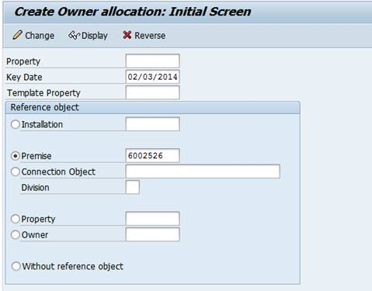
Figure 1 – Create Owner Allocation

Any one of the reference objects can be used for the creation of property objects. For big apartment complexes, the property object can be created with the connection object as the reference so that each Premise located at the complex can be mapped under a single property object.
A property is not tied to an address, but they serve as a way to group sites together so an owner may assume the responsibility for commodity service. It is therefore permissible to include installations belonging to other premises to be grouped to a single property object.
As tenants move out of the premise the same contract account will be reused for the property owner at each automatic move in. If there is a dispute (eg. Property related issue, Billing related issue) between a tenant and the owner, the employee will attempt to resolve the dispute and if necessary, escalate it to their Lead and then to a Supervisor by creating a new Ticket in Hybris C4C if required.
An owner must have at least one contract account when setting up SAP Property Object. The system allows for one property owner who has multiple properties to have all under the same or separate contract account.
Each premise/installation within the property will always be turned on in the owner’s name using the same contract account number. The Property object requires the service to be in the property owner’s (BP) name or the tenant’s (BP) name.

Landlord Agreement
A Landlord Agreement is a signed agreement by the property owner, which designates that they will take the responsibility for the service once a tenant moves out. The signed form can be provided back to SCE through email, postal mail or fax and sent to OTA team in CCC for processing. If the Landlord Agreement is received by another department other than the OTA team, a Ticket will be created (the receiving department shall upload the OA application to the Ticket) via Hybris C4C for CCC OTA team for processing the agreement. The user will access the list of Tickets assigned to them to complete the OTA changes.

Property Object
An Owner Allocation Property object can be created, updated, or reversed by the OTA Team. This functionality currently only exists in the back office, so users who need to perform this task will have access to the back office. Users in the front office will have visibility to the OTA information within Hybris C4C. There will be a standard view available in the Premise details which will show details of the owner, validity period and any additional activities for the owner allocation task.
The details of the Owner will also be available on the Premise data in S/4HANA.
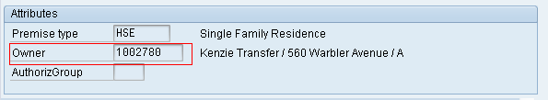
Figure 2 – Owner Details, Premise View

Owner Allocation Wait Time
- The day after a tenant is moved out of a location a workflow will generate the move-in for the owner at the location if there is not a pending move-in scheduled (for a new tenant) for that day. When the automatic move-in is created for the property owner, the system will automatically default to the rate category last billed to that property owner as defined by the enhancement W-CIM-CS-14 Landlord. The property owner can default a rate category which will be stored at the Installation with an installation fact specifically for Owner Allocation. This rate category will hold the Owners requested rate, so that when the tenant moves out and the owner is moved in, this rate will be applied during Move In. If there is no rate indicated in the Installation Fact, the Owner will be defaulted at Move in to the previous Tenants rate selected.
- Property Owner’s will be moved into the location by the workflow regardless of the time of the gap between tenants. Meaning the billable period for the property owner may be as short as 1 day.
- In the case that the tenant was moved out for dunning purposes the property owner will not be moved in automatically (APSE Action #603). The property owner would need to request a move-in or the current tenant a move-out. On the other hand, the owner will be moved in automatically by the enhancement, E-CIM-CS-14 Move out when customer is in dunning and no registered usage for 30 days.

Property Number
The Property number will be a numeric ID automatically assigned in SAP based on the configured number range, interval for number range will be 5000000000 to 5999999999. This will be generated internally by the system during creation of the property object.

Creating the Owner Allocation
To create the OA, or the Property, OTA Team – CCC will first have to choose a reference object on the selection screen. After that the following fields must be entered while creating the property object:
- Key Date
- Owner (which is a BP)
- Contract Account
- Create event
- Additional activities
- Validity Periods

Figure 3– Create Owner Allocation

Key Date
The key date field will signify the start date of the Landlord Agreement with the Owner of the Property. During conversion this date will be the contract date on the signed agreement.
Owner (BP)
The OTA Desk will specify the BP in the Owner field of the Property object. The agent will search for the BP with the information provided on the signed form. If the BP is not found, the agent will create the BP.
The Landlord Agreement form will be updated so that the BP can fill in their account information if they were a past or current SCE customer.
Create event
The create event flag will be checked so that the OA workflow initiates once a move out from the tenant is executed. Checking the Create Event flag causes a system-event to be raised on the tenant move-out, thereby triggering the OA workflow if there is a signed Landlord Agreement with the Owner. If the box is not checked the owner is considered the owner of the property but will not be moved in. Based on current processes this will need to always be checked, an enhancement was logged and will automatically check this box at OA set up.
Additional Activities
Letter/Notification will be generated automatically by the enhancement W-CIM-CS-14 Landlord and will be sent on owner auto move-in and on cancellation of landlord agreement via OpenText based on customer preferences.
Contract Account
A new CA can be created for each property. The contract account will be used each time the owner takes over. The property object can only have one contract account associated to it. The enhancement W-CIM-CS-14 Landlord will be triggered to move the owner back into the premise automatically using this CA. A BPEM Case will be generated whenever there is an exception generated by the S/4HANA for the OTA Desk to perform the manual move-in via Hybris C4C. The user will access into BDEx to view the list of BPEM cases assigned to them in the Personal Worklist via Dynamic WorkCenter (transaction code: /n/BTI/DWC) (Refer to Section 2.10 for details). If the exception is a system issue, the employee will submit a defect ticket to IT.
Validity Dates
The validity dates will specify the seasonal period for which the Owner requests to take responsibility of the Property. Currently at SCE these validity dates would be left to the default of all year (1/1 to 12/31). SCE does not currently offer seasonal OA’s, a decision was made to not offer such functionality at this time (APSE Decision #243). If SCE wanted to use a seasonal program going forward they could allow for owners to select plans such as winter (11/1 to 4/30) or summer (5/1 to 10/31).

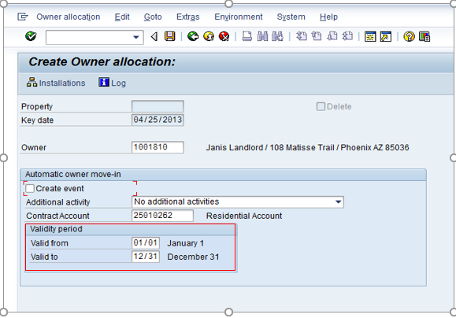Figure 4 – Owner Allocation with Validity dates.

Changing the Owner Allocation
To change the existing OA, or the Property, OTA Team – CCC will first have to identify the property number on the selection screen. After that the following fields must be entered while creating the property object:
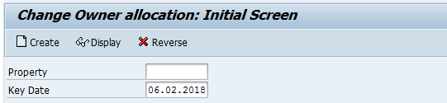
NOTE: The option Reverse is available when there is a need to remove the existing property when required.

When seeing the list of properties, a new property can be added and/or existing property can be removed based on the property owner’s request.

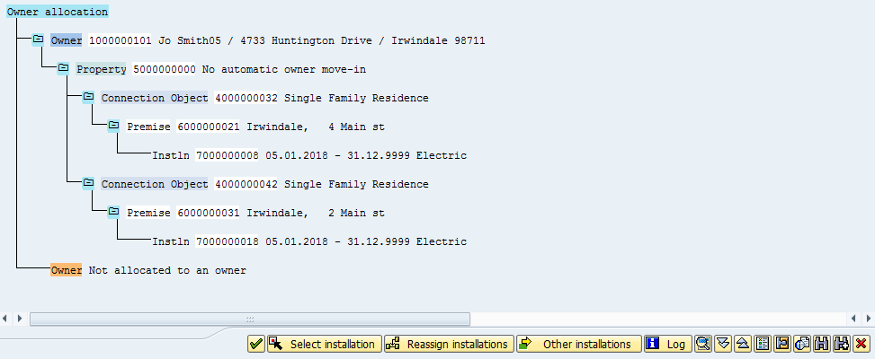

The button Other installation will be used to add additional property as required (refer to Section 2.1.1) and Select/Reassign Installation can be used when there is a need to remove a property.

Process / Performance Improvement
- Able to search for the Business Partner and property information within the SAP system.
- One or more properties can be removed without affecting others within the same SAP property object.
- Ability to remove a property from one landlord OA agreement to a different landlord OA agreement within the same today. Today, we must wait at least one day before adding the property to another landlord OA agreement.

Prerequisites and Inputs
- Signed Landlord Agreement
- Business Partner
- Contract Account
- Installation

General Assumptions
- Duplicated Business Partners may still exist, despite the system controls to prevent users from creating duplicates. As a result, several properties may be created in error if the user does not locate the existing BP in the system prior to creating another.
- No Move In document is required to have an Owner Allocation Property in SAP
- OTA Desk users should have access to view, create, change and reverse OA’s
- All users will have view access to OA’s, while other users will have create, change, and reverse functionality.

Business Process Hierarchy
Level 1 FO or BO | Level 2 Business Process(BPD) | Level 3(Sub Processes) | Level 4(SAP Transaction Codes
OTA Desk/Summary Billing/EDI Desk (Back Office) | Owner Allocation Process | Create Owner Allocation  Change Owner Allocation  Display Owner Allocation  Reverse Owner Allocation  Dynamic WorkCenter | ES51, ES52 ES53, ES54, /n/BTI/DWC
CCC/GC Services, OTA Desk, BCD | Move In  Move Out | Complete Move In  Complete Move Out | EC50E  EC55E
OTA desk, CCC/GC Services, BCD, Billing, and Credit | Owner Allocation Process | Display Owner Allocation | ES53

Process Flows

Setting up Owner Allocation
This process flow is for setting up owner allocation based on the form provided by the landlord.

Process Flow Steps
Step | Description of Step | Front Office/ T-Code | Role(s)
10 | Start | N/A | N/A
20 | Customer calls in for owner allocation setup  If customer initiates process with CSR. Send Outbound Communication to Customer with form. | N/A | Customer
30 | Provide OTA Form to Complete, Sign and Return by Mail  If customer initiates process with CSR they are sent an OTA form for Owner Allocation Setup to complete.  Refer to process CIM-CS-11 for details on Manage Outbound Request. | Open Text | CCC/BCD OA & Summary Billing/EDI Desk
40 | Customer Returns Completed OTA form  OTA Form completed and returned to SCE  Refer to process CIM-CS-09 for details on Manage Inbound Request. | N/A | Customer
45 | Validate Information on Form  Decision point, verify customer listed on OTA form matches Owner listed on Landvision. If Customer is Owner, proceed to step 47, if not proceed to step 110.  CONTROL: OTA Desk employee reviews each received OTA forms to verify it is complete and has been signed by the property owner prior to creating the Owner Allocation (ie. Landlord agreement) in SAP ISU using its information | NA | CCC/BCD OA & Summary Billing/EDI Desk
47 | Process CIM-CS-09 Manage Inbound Request  This is to scan the document and store in the system. Go to step 50 | NA | CCC/BCD OA & Summary Billing/EDI Desk
50 | Search for Address on Form  Each address on the form is found one at a time in Front Office premise search. | C4C | CCC/BCD OA & Summary Billing/EDI Desk
60 | Single Address  Decision point needed, if customer listed only a single address proceed to step 80. Otherwise proceed to step 70. | C4C | CCC/BCD OA & Summary Billing/EDI Desk
70 | Address Found  Decision point needed, if address is found, proceed to step 80. Otherwise, proceed to step 130. Refer to process CIM-CS-11 for details on Manage Outbound Request. | C4C | CCC/BCD OA & Summary Billing/EDI Desk
80 | BP Exists for the Property Owner  Decision point: once address is found need to find and confirm BP, if BP does not exist perform step 100. Otherwise, proceed to step 110 | C4C | CCC/BCD OA & Summary Billing/EDI Desk
90 | Create BP for Property Owner  Business partner must be created for property owner. Refer to process CIM-CS-01 for details on Manage Business Partner. | C4C | CCC/BCD OA & Summary Billing/EDI Desk
100 | Select/Create Contract Account  Once BP is found need to find and confirm Contract Account (CA), if a CA does not exist the user must create a Contract Account.  Refer to process CC-FI-01 for details on Manage Contract Account. | C4C | CCC/BCD OA & Summary Billing/EDI Desk
110 | Create Property  With confirmed contract account and premise trigger transaction launch to create the property | ES51 | CCC/BCD OA & Summary Billing/EDI Desk
120 | Create Activity for Owner Allocation Setup  At this point an OA was requested and saved, the agent will create activity for owner allocation setup. | C4C | CCC/BCD OA & Summary Billing/EDI Desk
130 | Send applicable Outbound Communication to BP  Send the customer the applicable Outbound Communication related to the success/failure of the OA set up. | Open Text | CCC/BCD OA & Summary Billing/EDI Desk
140 | End  The process comes to an end | N/A | N/A

Tenant Request for Move-Out
This process flow is for the owner allocation process when the workflow is triggered based on move-out.

Process Flow Steps

Step | Description of Step | Front Office / T-Code | Role(s)
5 | Self-Service Turn off Received (SCE.COM/IVR)  Go to step 60 | N/A | N/A
10 | IVR  Go to step 20 | N/A | N/A
20 | Call Routed to Agent  Tenant call for move out from premise. | N/A | N/A
30 | Agent Accept Call | N/A | N/A
40 | Manage business Partner  Confirm Business partner. | C4C | CCC/BCD
50 | Process Move Out  Agent Process move Out. And go to step 60. | C4C  EC55E | CCC/BCD
60 | Owner Allocation workflow is triggered | N/A | N/A
70 | Dunning Related Case?  Decision Point, if the tenant was turned off due to dunning, proceed to step 75. Otherwise proceed to 80. | N/A | N/A
75 | Manage Collections (Dunning) – Manage Credit and Collections (CC-FI-04)  Tenant disconnected for dunning. Proceed to step 130. | N/A | N/A
80 | Owner Allocation waits for day after move out | N/A | N/A
90 | New Tenant Moved in Yet?  Decision Point, if a new tenant move in is pending, new tenant will be moved in, otherwise, proceed to step 100. | N/A | N/A
95 | Process Owner Move In (Refer to Process CIM-CS-02 Handle Customer Move-in/Out – Contract New)  Once completed, go to step 130 | EC50E | CCC/BCD, OTA Desk, Summary Billing/EDI desk
100 | Process Owner Move In (by W-CIM-CS-14 Landlord)  The Property Owner will only be moved in if there is no tenant move in pending and previous tenant was not disconnected for dunning. | N/A | N/A
105 | Move In Successful?  Decision Point, if Yes, go to step 110. If not, go to step 130 | N/A | N/A
108 | Create BPEM Case  Go to step 109 | N/A | N/A
109 | Correction Resolution  To provide resolution the case assigned  Go to step 130 | /n/BTI/DWC | CCC/BCD OA
130 | End  Process comes to an end. | N/A | N/A

Changing Owner Allocation
This process flow is for the owner allocation changes requested by a landlord.

Process Flow Steps
Step | Description of Step | Front Office/ T-Code | Role(s)
10 | Start | N/A | N/A
20 | Customer calls in for owner allocation setup  If customer initiates process with CSR. Send Outbound Communication to Customer with form. | N/A | Customer
30 | Provide OTA Form to Complete, Sign and Return by Mail  If customer initiates process with CSR they are sent an OTA form for Owner Allocation Setup to complete.  Refer to process CIM-CS-11 for details on Manage Outbound Request. | Open Text | CCC/BCD OA & Summary Billing/EDI Desk
40 | Customer Returns Completed OTA form  OTA Form completed and returned to SCE  Refer to process CIM-CS-09 for details on Manage Inbound Request. | N/A | Customer
45 | Process CIM-CS-09 Manage Inbound Request  This is to scan the document and store in the system. Go to step 50 | NA | CCC/BCD OA & Summary Billing/EDI Desk
47 | Validate Information on Form  Decision point, verify customer listed on OTA form matches Owner listed on Landvision. If Customer is Owner, proceed to step 50, if not proceed to step 110.  CONTROL: OTA Desk employee reviews each received OTA forms to verify it is complete and has been signed by the property owner prior to creating the Owner Allocation (ie. Landlord agreement) in SAP ISU using its information | NA | CCC/BCD OA & Summary Billing/EDI Desk
50 | Search for Address on Form  Each address on the form is found one at a time in Front Office premise search. | C4C | CCC/BCD OA & Summary Billing/EDI Desk
60 | Verify Property for changes  Verify the document with what’s been updated in the S/4HANA and provide changes as requested. | C4C/ES53 | CCC/BCD OA & Summary Billing/EDI Desk
70 | Property Found  Decision point needed, if property is found, proceed to step 80. Otherwise, proceed to step 110. Refer to process CIM-CS-11 for details on Manage Outbound Request. | C4C/ES53 | CCC/BCD OA & Summary Billing/EDI Desk
80 | Change Property  Provide changes to the property object. This can be either the information in the property and/or assign or de-assign new/existing premise respectively | ES52 | CCC/BCD OA & Summary Billing/EDI Desk
90 | Changes completed  Decision point: If yes, proceed to step 100. If not, complete the changes as required. | ES52 | CCC/BCD OA & Summary Billing/EDI Desk
100 | Create Activity for Owner Allocation Change  Create activity to log interaction with the customer request. Proceed to step 110 | C4C | CCC/BCD OA & Summary Billing/EDI Desk
110 | Send applicable Outbound Communication to BP  Send the customer the applicable Outbound Communication related to the success/failure of the OA set up. | Open Text | CCC/BCD OA & Summary Billing/EDI Desk
140 | End  The process comes to an end | N/A | N/A

Reversing Owner Allocation
This process flow is for the owner allocation reversal requested by a landlord. This can involve one or more premises to be assigned/de-assigned or the entire property object.

Process Flow Steps
Step | Description of Step | Front Office/ T-Code | Role(s)
10 | Start | N/A | N/A
20 | Customer calls in for owner allocation setup  If customer initiates process with CSR. Send Outbound Communication to Customer with form. | N/A | Customer
30 | Provide OTA Form to Complete, Sign and Return by Mail  If customer initiates process with CSR they are sent an OTA form for Owner Allocation Setup to complete.  Refer to process CIM-CS-11 for details on Manage Outbound Request. | Open Text | CCC/BCD OA & Summary Billing/EDI Desk
40 | Customer Returns Completed OTA form  OTA Form completed and returned to SCE  Refer to process CIM-CS-09 for details on Manage Inbound Request. | N/A | Customer
45 | Process CIM-CS-09 Manage Inbound Request  This is to scan the document and store in the system. Go to step 50 | NA | CCC/BCD OA & Summary Billing/EDI Desk
47 | Validate Information on Form  Decision point, verify customer listed on OTA form matches Owner listed on Landvision. If Customer is Owner, proceed to step 47, if not proceed to step 110.  CONTROL: OTA Desk employee reviews each received OTA forms to verify it is complete and has been signed by the property owner prior to creating the Owner Allocation (ie. Landlord agreement) in SAP ISU using its information | NA | CCC/BCD OA & Summary Billing/EDI Desk
50 | Search for Address on Form  Each address on the form is found one at a time in Front Office premise search. | C4C | CCC/BCD OA & Summary Billing/EDI Desk
60 | Verify Property for changes  Verify the document with what’s been updated in the S/4HANA and provide changes as requested. | C4C/ES53 | CCC/BCD OA & Summary Billing/EDI Desk
70 | Property Found  Decision point needed, if property is found, proceed to step 80. Otherwise, proceed to step 110. Refer to process CIM-CS-11 for details on Manage Outbound Request. | C4C/ES53 | CCC/BCD OA & Summary Billing/EDI Desk
80 | Change Property  Provide changes to the property object. This can be either the information in the property and/or assign or de-assign new/existing premise respectively | ES52 | CCC/BCD OA & Summary Billing/EDI Desk
90 | Changes completed  Decision point: If yes, proceed to step 100. If not, complete the changes as required. | ES52 | CCC/BCD OA & Summary Billing/EDI Desk
100 | Create Activity for Owner Allocation Change  Create activity to log interaction with the customer request. Proceed to step 110 | C4C | CCC/BCD OA & Summary Billing/EDI Desk
110 | Send applicable Outbound Communication to BP  Send the customer the applicable Outbound Communication related to the success/failure of the OA set up. | Open Text | CCC/BCD OA & Summary Billing/EDI Desk
140 | End  The process comes to an end | N/A | N/A

3rd Party and SCE Legacy System Integrations
3rd Party or SCE Legacy System Integration | Description of Integration and Required Change to 3rd Party or SCE Legacy System | Estimated Complexity of 3rd Party or SCE Legacy system change
Not Applicable

Data Elements
There will be four processes involved within managing the Owner Allocation in SAP and they have the same data elements:
- Create Owner Allocation
- Change Owner Allocation
- Display Owner Allocation
- Reverse Owner Allocation

Owner Allocation Data Elements
Field | Type | Comments
Owner | Required | This is the BP number of the Property owner.
Contract Account | Required | This is the CA used for the creation of new Contract for the owner.
Create Event | Required | Flag to specify if auto move in will occur. This will default as checked via enhancement.
Validity Dates | Optional | Validity period of landlord agreement; default to 0101 and 1231.
Key Date | Required | Date from which Owner Allocation property is valid
Property | Required | Represents the Technical master data groupings to be associated to the property owner’s account at the time of auto-move in.
Installation | Required | Represent a specific service a property owner has requested to be part of Owner Allocation property.

Source Systems and Data Volumes
- Source: CSS System
- Data Volume: There are around 345,000 properties in SCE which translates to around 1,000,000 installations related to owner allocation.

Cloud for Customer (C4C) Integration

Processes
Owner Allocation Setup will be done via S/4HANA, option will be available for front office agent to display OA information.

C4C Views
Screen will be available in C4C system where Owner BP will be visible with the tenant master data.

Activity
A new Activity can be created after the property owner request has been created or changed in the system.

Exception Management Requirements
Below are the Exception management requirement for Owner Allocation Process
User Exception Scenario / Description | User Group | Initiated by | Work Distribution
Get triggered when an active OA exists but the Owner is not moved in when the tenant moves out due to any unexpected reason except dunning related case | OTA Desk | System | Pull

Process Risks and Mitigation
Only CCC/BCD OTA desk and Summary Billing/EDI desk users will have access to create, update, and reverse OA. All other users will have view only access.

Risk Statement | Mitigation
There may still be duplicated BP in the new system due to human error | Routine data cleansing will have to be done in order to reduce the number of duplication to mitigate the risk
If the “Create Event” field is not checked by the user during OA set up, the system will not initiate workflow to move-in the owner upon the tenants move-out | A report can be generated based on the Checkbox field being checked/not checked to mitigate the risk and ensure that the workflow is initiated when move out occurs.
If the OTA is lost then SCE does not have legal rights to execute the agreement. (Ties to high level risk: Noncompliance or misinterpretation with regulatory and legislative requirements may lead to misstatement of financial statements, penalties, fines and/or prosecution from governing regulatory bodies.) | OTA Desk employee reviews each received OTA forms to verify it is complete and has been signed by the landlord prior to creating the Owner Allocation (ie. Landlord agreement) in SAP ISU using its information”

Key Performance Indicators
The following have been identified as KPI’s at Southern California Edison, along with the means of measuring each KPI and the current measurement statistic for each KPI:
Measured KPI | Description | Measurement Method | Current Statistic
N/A
(Refer to the general document in APSE –General Document #31)

Key Metric Definition
The following have been identified as key metrics at Southern California Edison that require business rule for calculation:
Key Metric | Description | Business Rule | Reference
N/A

Controls and Regulatory Rules
Completeness of the data:
- Owner Master Data (ex.BP, CA) and tenant Master Data (BP, CA, active Contract) will be identified as required to set up owner allocation.
Validity of the data:
- The property owner listed in the property object will have to be set up as a BP.
- The premise can only be listed under one Property.
Accuracy of the data:
- Back office agents will be trained to look for any pending move-ins before they cancel a landlord agreement.
- All required fields must be completed and if not, the employee will need advise the property owner to resubmit the form.
- If an address(es) is not found in our system, the employee will need to advise the property owner to resubmit the form.
Restricted access to the data:
- BCD, CCC OTA desk and Summary Billing/EDI desk users will have access to create, update, and reverse OA. All other users will have view only access.

Requirement  ID (from RTM) | “As-Is” Control Requirement | “To Be” Risk Statement | “To-Be” Control Activity” | Control Automation (manual, IT dependent- manual, automated | Relevant technical identifier or RICEFW reference
New - CONTROL-ZZZ-5047 |  | If the OTA is lost then SCE does not have legal rights to execute the agreement. (Ties to high level risk: Noncompliance or misinterpretation with regulatory and legislative requirements may lead to misstatement of financial statements, penalties, fines and/or prosecution from governing regulatory bodies.) | OTA Desk employee reviews each received OTA forms to verify it is complete and has been signed by the landlord prior to creating the Owner Allocation (ie. Landlord agreement) in SAP ISU using its information”. (Step 45) | Manual | N/A

Security Considerations
Role | Transaction Code (T-Code) | T-Code Description | Authorization Attributes | SOD Conflicts (Yes/No)  If SOD Conflicts Yes. Identify the 2 conflicting t-codes
Owner Allocation Processing – all users | C4C (Workcenter: Call Center) | Display Owner Allocation | Display
Owner Allocation Processing - – CCC/BCD OA | /n/BTI/DWC | Dynamic WorkCenter | View
Owner Allocation Processing – CCC/BCD OA & Summary Billing/EDI Desk | ES51 | Create Owner Allocation | Create
Owner Allocation Processing – CCC/BCD OA & Summary Billing/EDI Desk | ES52 | Change Owner Allocation | Change
Owner Allocation Processing – CCC/BCD OA & Summary Billing/EDI Desk | ES53 | Display Owner Allocation | Display
Owner Allocation Processing – CCC/BCD OA & Summary Billing/EDI Desk | ES54 | Reverse Owner Allocation | Reverse
Owner Allocation View– All Users (Billing/Credit, GC Services, CCC, & BCD | ES53 | Display Owner Allocation | Display

Custom Program/Transaction Codes

Custom Program | Authorization Grp | Custom T-code | Authorization Object used in the authorization check statement
N/A

3.3 Custom Table/Transaction Codes
Custom Table | Authorization Grp Assigned | Custom T-code for the Table | Table Access (display/update)
N/A

Technical Considerations

RICEF-W Assessment
All of the Forms, Reports, Interfaces, Conversion items, Enhancements and Workflows (RICEF-W) that have been identified for this BPD are detailed in the tables below and will represent the totality of all RICEF-W items documented at the time of sign-off of this BPD. Any RICEF-W items that are identified after this BPD receives final sign-off will only be managed within Southern California Edison’s APSE environment and not within this document.

Reports
Description (include the Business Purpose) | Complexity  (L, M, H, VH) | Reference ID
The system shall enable a user to generate a report listing all the properties that are enrolled in an owner tenant agreement for a landlord by BP, including all service addresses and their participation status. | M | R-CIM-CS-14 Owner Allocation by Parameter Report

Interfaces
Description (include the Business Purpose) | Complexity  (L, M, H, VH) | Reference ID
N/A

Conversion
Description (include the Business Purpose) | Complexity  (L, M, H, VH) | Reference ID
C-CIM-CS-14 - PROPERTY  ISUPROD (Owner Allocation) | M | 133

Enhancements
Description (include the Business Purpose) | Complexity  (L, M, H, VH) | Reference ID
E-CIM-CS-14 OA Create Change and Display  The system allows the users to create, change, and display owner allocation (With the event checkbox pre-checked) | M | 1690
E-CIM-CS-14 OA Eligibility  The system shall automatically determine if a service address is eligible to be enrolled in an owner tenant agreement (e.g., based on property classification similar to Landvision website) and if not, not allow the user to enroll the property. | M | ##
E-CIM-CS-14 Move out when customer is in dunning and no registered usage for 30 days | M | 1691

Forms
Description (include the Business Purpose) | Complexity  (L, M, H, VH) | Reference ID
F-CIM-CS-14 OTA Form  OTA Application Form– Manually Initiated | M | 1685
F-CIM-CS-14 OA New/Cancellation Letter  OA Cancellation and OA Cancellation (New Party Application)- Manually Initiated | M | 1686
F-CIM-CS-14 List of Properties for BP  List of Properties for BP (OTA Property List Letter) – Manually Initiated | M | 1687
F-CIM-CS-14 OA Declined Rule #5  OA Declined Rule #5 and #6– Manually Initiated | M | 1688
F-CIM-CS-14 OA Missing Information  OA Missing Information– Manually Initiated | M | 1689
F-CIM-CS-14 OA Cancellation Form  OTA Cancellation Application – Manually Initiated | M | 2186
F-CIM-CS-14 Letter to Owner after tenant moves out  Letter/Notification sent to customer once tenant move out and owner move in | M
F-CIM-CS-14 Letter to owner automated move-in Automated Letter to owner once tenant Move in | M

Workflows
Description (include the Business Purpose) | Complexity  (L, M, H, VH) | Reference ID
W-CIM-CS-14 – Landlord  Landlord (workflow enhanced to automatically handle tenant move out)  If a new owner tenant agreement is entered in the system for a landlord, the system shall automatically issue move-ins into the landlord name for all vacant premises under that address.  If a new owner tenant agreement is entered in the system for a landlord, the system shall not modify existing contract agreements with tenants (i.e., people already living at the address) due to the new OTA  If a user cancels an owner tenant agreement in the system for a landlord, the system shall leave the contract and contract account in the tenant name(s) and not disconnect their power.  If a move-in is cancelled for a tenant, the system shall automatically keep the address in property manager name OR put it back in the property manager name if an active OTA exists and process all necessary deposit or energy charge adjustments.  If a move-out is reversed for a tenant and an active OTA exists, the system shall automatically put the address back into the tenant name and process all necessary deposit or energy charge adjustments.  If a new owner tenant agreement is entered in the system for a landlord, the system shall not modify any PENDING move-ins or outs requests for new/existing tenants (allow them to process as scheduled) for the address. | M | 1133

IDEX Considerations
- If a tenant moves in or moves out to a premise either in CCA or DA territory, the enrollment or de-enrollment will occur in the background based on the IDEX pre-defined rules occuring in UB-ID-01 Section 4.2-IDEX consideration..
- If an owner moves back in to the premise, the enrollment status will be carried over based on the IDEX pre-defined rules

Production System Cut-over Considerations
Active and/or future landlord agreements will need to have both Business Partner and Contract Account created. As part of the cutover process, a communication to the property owners will be required to provide the new Property numbers assigned in SAP.

4.5 Other Considerations
- N/A

Change Management
5.1 Change Impacts
Change Element Short Description | Change Impact Category | Audience Group(s) | Impact | Business Effort
The SAP Property object is the link of an owner to a premise associated with a business partner, contract accounts and premise. There can be multiple SAP property objects if you are going to solo bill each of the units or can have 1 property object with multiple contracts and premise associated with it. Users will need to be trained on the new Owner Tenant Agreement (OTA) property object | Process | CS-CSOD-CCC All. CS-BCD-All | Low | Low
The Owner Tenant Agreement (OTA) indicator in SAP is a field with the owner's name and is located at the business partner level. The current indicator in CSS is an icon. Users need to go to a separate window to determine the name of the owner | Process | CS-CSOD-CCC All, CS-BCD-All | Low | Low
SAP has the ability to set up the owner allocation before the meter is set. SCE can add the contract as early as new construction and we will have the ability to bill owner as soon as meter is set with minimal idle usage. Currently a meter is required to add an OTA contract. | Process | CS-CSOD-CCC All, CS-BCD-All | Low | Low
In SAP, the tenant will have to request a move out or the owner will need start service to reconnect after a dunning lock has been issued. Presently, a move out is issued if a tenant is in disconnect for 30+ days. This new process should benefit the owner who will now take responsibility when they call in for service.  Users will need to advise owners the reason for the service being off and will need to issue a move in request for the owner. | Process  Benefit/Improvement,  Job Roles | CS-CSOD-CCC All;CS-CSOD-RSO-Credit;Ext-Customers-Residential;Ext-Customers-Commercial/Industrial;CS-BCD-All | Medium | Medium
Authorized users will be able to run Owner Allocation reports in SAP. Currently no reports are available for OA information. The OTA team can request for data from CSS from another group. Data can be used by the OA team to determine the number of OA customers, number of contracts associated with OA's etc. OTA team will be able to obtain customer information and program enrollment data when needed. | Benefit,  Improvement/  Decision Making,  Job Roles | CS-CSOD-CCC All | High | High
Customer Contact Center (CCC) will need to convert current OTA documents (email, fax etc.) into soft copies (pdf's etc.) to attach to the BP level. This will allow the OTA team to store documents at the BP and open text. It will save storage space of hard copy documents as well as provide the front office visibility to the contracts for inquiries. This will increase customer satisfaction and first call resolution. Currently all OTA documents are hard copies and stored until they are archived. If research is required, the OTA team needs to find and pull out the contract. | Process; Benefit/Improvement; Culture Shift; Technology | CS-CSOD-CCC All;CS-BCD-All | Low | Low
The Owner Allocation paper contract can be canceled for the previous owner and begin a new paper contract for a new owner for the same premise on the same date. The functionality to end and start a new contract is currently a pain point for the OA desk and can be alleviated with this ability. Customers currently have to wait for the next business date to begin a new OA contract which may cause a disruption in service. | Benefit/Improvement; Process | CS-CSOD-CCC-OLS | Medium | Medium
The OA desk will need to contact the customer for follow up on certain OA exception cases to ensure that OA workflow completes as needed. Currently the OA desk does not make customer contact. They typically will send the response back to the agent to follow up with the customer. | Culture Shift; Decision Making; Job Roles | CS-CSOD-CCC All | Low | Medium
During post conversion, if the owner has any questions regarding their contract, the Owner Allocation (OA) desk will need to search in 3 locations to search for documentation depending on when the OA contract was started. Current OA contracts will not be added in SAP unless the CCC adds these contracts post implementation. Only new OA’s will have the contract attached at the BP level. For any disputes regarding OA contract information, the desk will need to search different locations (e.g. sharepoint, paper copy etc.) for a copy. As more new paper contracts are received, the OA desk will store all paper contracts within SAP. | Benefit/Improvement;  Process;  Decision Making | CS-CSOD-CCC All | Low | Low

Below is a description of each:
Change Element Short Description: Describes the ‘As-Is’ scenario and what is changing.
Change Impact Category: Determined by asking the questions below.
- Staffing Levels - Is the work effort increasing or decreasing (staffing levels), and how (e.g., task automation, new process/tasks)?
- Job Roles - Will the responsibilities, authority, or required skills for a job or job roles change? Will people be reporting to new leaders? Will managers’ responsibilities change?
- Compensation / Performance - Will the changes have such an impact on roles of an individual that merits a change in how they are compensated or how their performance will be evaluated? What behaviors are rewarded and recognized?
- Organization Structure - Is the ownership of the Process or Data changing (think departments, jobs, or roles, not individuals)?
- Decision Making - Will any of the changes impact how decisions are made, by or between, business units / departments? Who makes them, how they determine the criteria for making a change?
- Culture Shift - Will organizational value systems impact the way change happens or be impacted by the change? What are the underlying values of the organization that will directly influence the way change will be accepted and how much work will ultimately be required to ensure successful outcomes for the business?
- Location / Facilities - Will the change impact the physical location where they process is being implemented or require changes to the facilities to enable the process to be effective?
- Process - Any change to the current process (e.g. manual process becomes automatic, or vice versa)? Are there new processes being introduced or an old process being decommissioned? Is there a requirement to change an existing business rule or business policy? Will new business rule or policy needs to be introduced and enforced or complied to?
- Regulatory/ Legal - Are there any legal / regulatory requirements that might be impacted
- Technology - Are other applications impacted (e.g., going away, becoming read-only), or are there new requirements (e.g., new SW / HW, new version)
- Benefit/Improvement - Will there be an improvement or benefit to any of the stakeholders because of this change. (Be sure to include any pain points that are being alleviated)
- Other - Are there emotional implications stemming from any of these changes (think of buy-in issues or fears)
Audience Group(s): These are the affected departments, divisions etc…
Impact: The following were used to determine the impact:

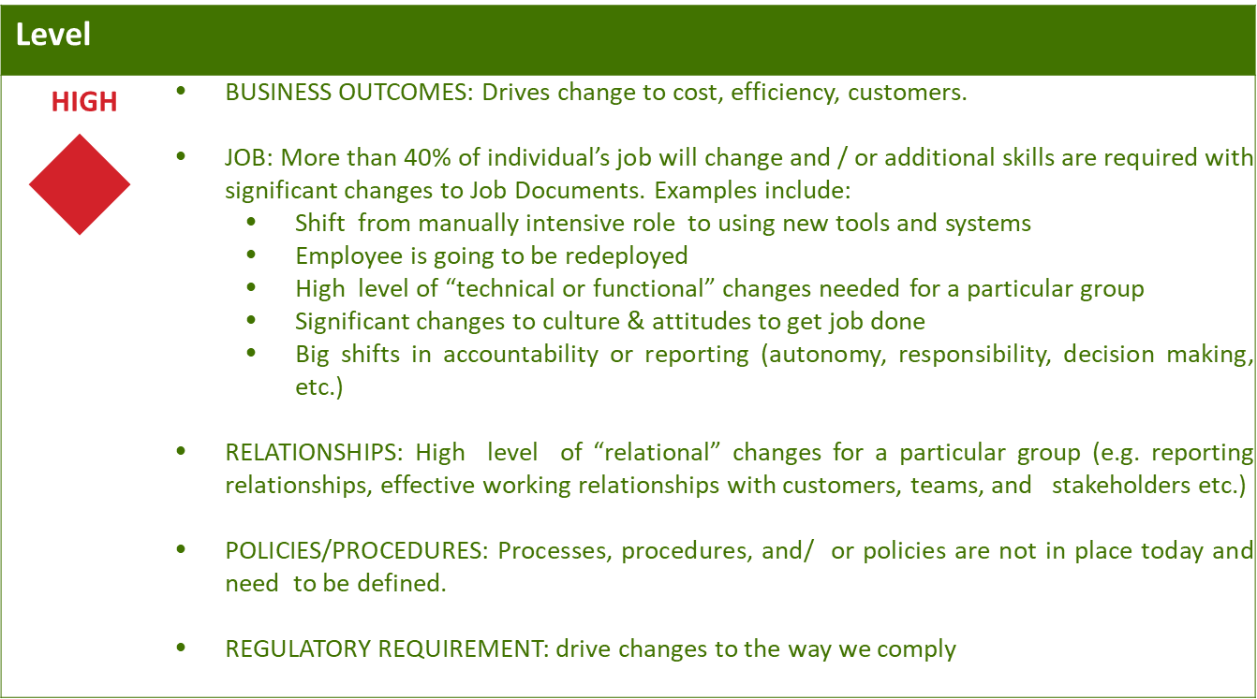
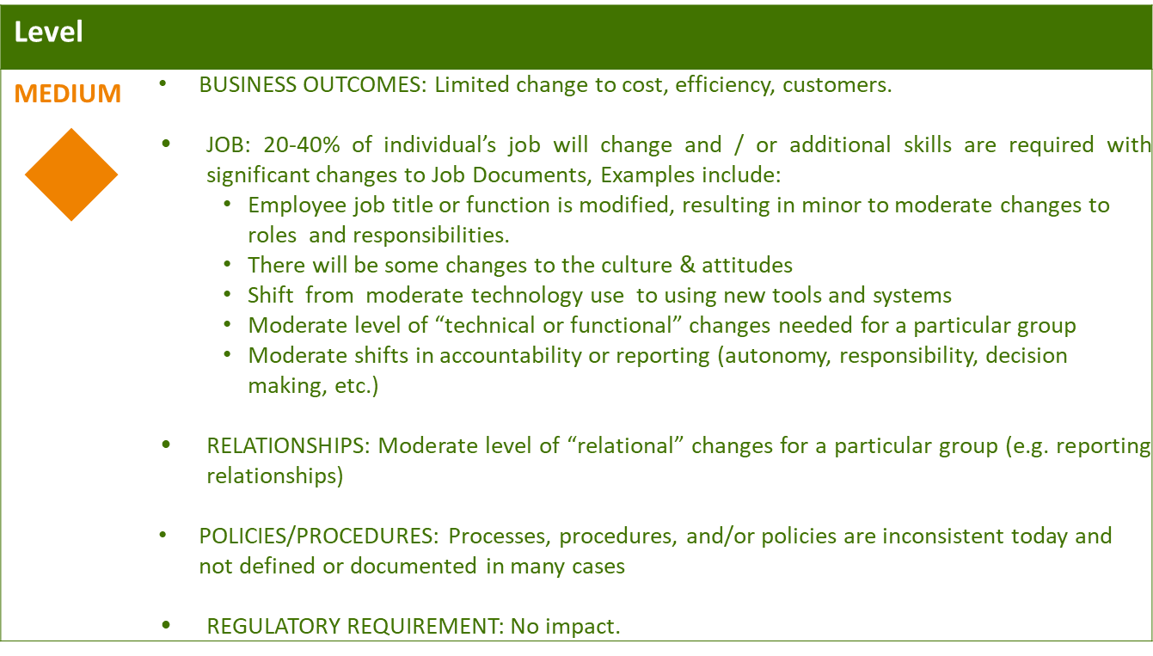
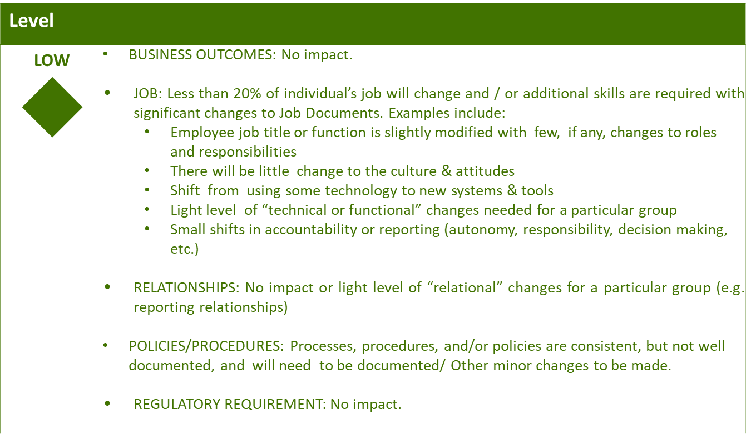

Business Effort: Initial assessment of the impact to the business High, Medium, Low

6. Requirements

Requirement # | APSE Requirement # | Requirement Description

7. Appendix

Visio Template

OA Visios

